Lab Objective

Configuring Quotas

**Lab Procedures**

**1.** On Server01, with Server Manager, click Tools > File Server Resource Manager. The File Server Resource Manager console opens.

**2.** Under Quota Management, click Quota Templates. Then right-click Quota Templates and select Create Quota Template. The Create Quota Template dialog box opens.

**3.** In the Template name text box, type **QuotaTemplate1**.

**4.** In the Space limit section, in the Limit text box, type **10** and specify the unit MB.

**5.** Select Soft quota, as shown in Figure 5-1.

|  |  |
| --- | --- |
| Question 1 | What is the difference between a hard and soft quota. |

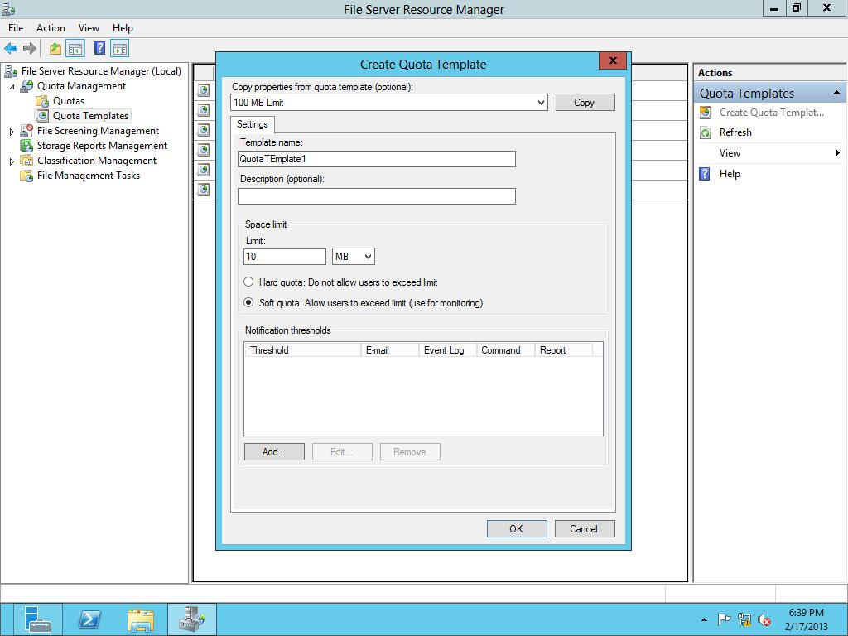

Figure 5-1

Creating a quota template

**6.** To add a notification, click the Add button. The Add Threshold dialog box opens.

**7.** Click the Event Log tab.

**8.** Click the Send warning to event log check box, as shown in Figure 5-2.

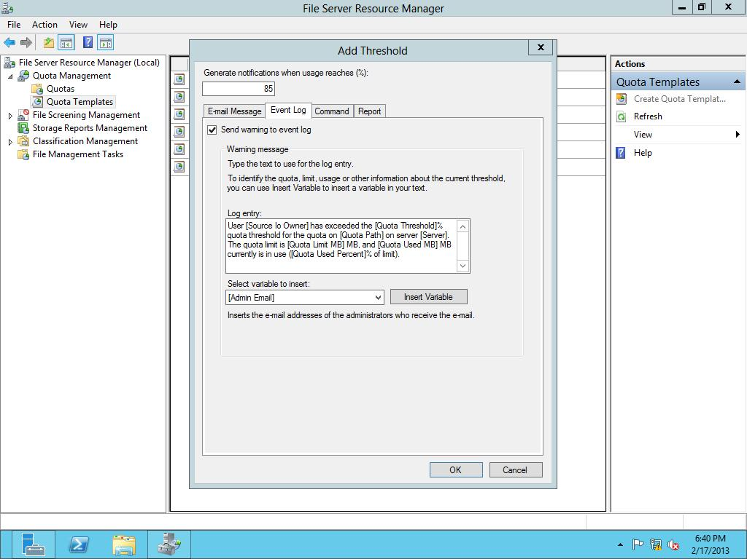

Figure 5-2

Adding an event log notification

**9.** Click OK to save your notification threshold and close the Add Threshold dialog box.

**10.** Click OK to close the Create Quota Template dialog box.

**11.** Click the Quota Templates node, and take a screen shot of the File Server Resource Manager window by pressing Alt+Prt Scr and then paste it into your Lab05_worksheet file in the page provided by pressing Ctrl+V.

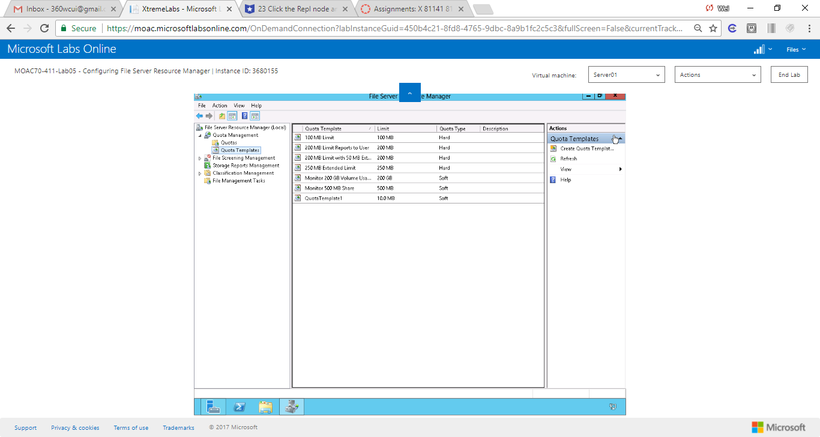

Figure Click OK to close the Create Quota Template dialog box

**12.** Under the Quota Management node, click the Quota Templates node.

**13.** Right-click the QuotaTemplate1 and click Create Quota from Template. The Create Quota dialog box opens.

**14.** In the Quota path, type **c:\Share1** in the Quota path text box, as shown in Figure 5-3.

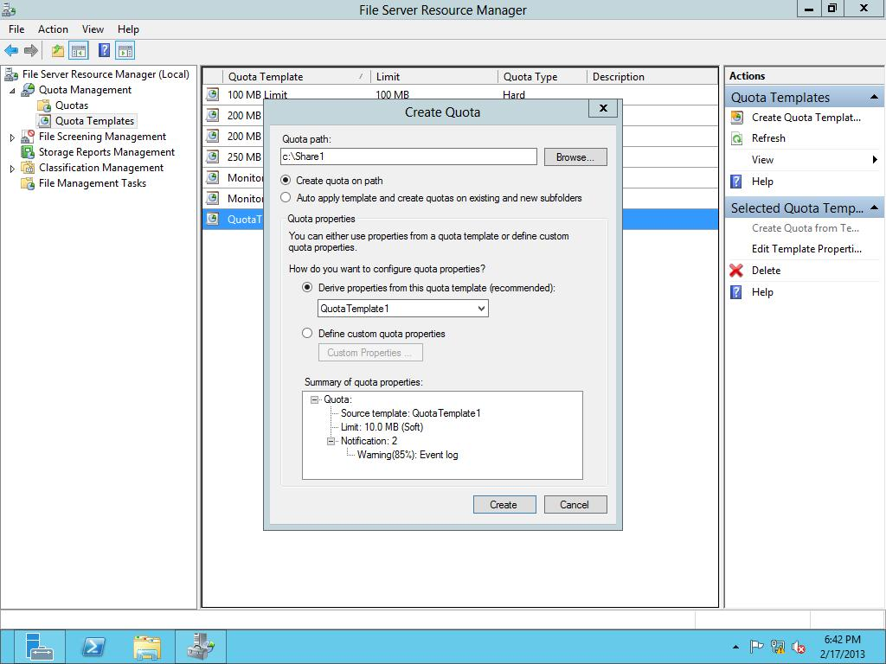

Figure 5-3

Creating a quota from a template

**15.** Click Create.

**16.** From the \\RWDC01\software folder, copy the following files to the C:\Share1 folder:

* ADMXMigrator.msi
* NM34_x64.exe
* System Center Monitoring Pack for File and Storage Management.msi
* Windows8-RT-KB2769034-x64.msu

**17.** On Server01, open the Event Viewer and look for an entry in the Applicationlogs showing that the quota has been exceeded.

|  |  |
| --- | --- |
| Question 2 | What event ID was used for the quota to be exceeded? 12325 |

**18.** Take a screen shot of the Event Viewer window by pressing Alt+Prt Scr and then paste it into your Lab5_worksheet file in the page provided by pressing Ctrl+V.

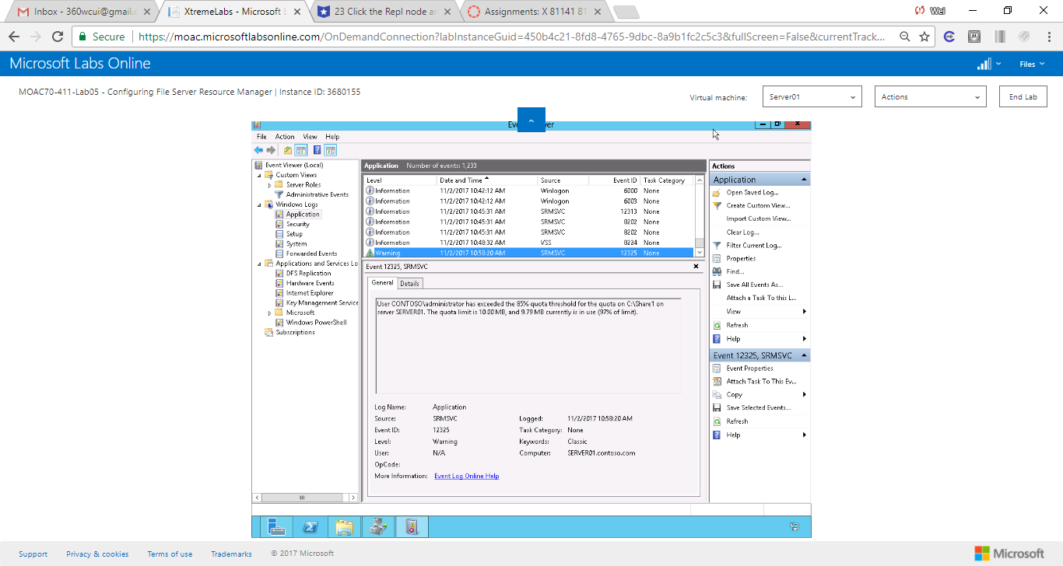

Figure On Server01, open the Event Viewer and look for an entry in the Application logs showing that the quota has been exceeded. The event ID is 12325.

**19.** Close Event Viewer.

**Lab Summary**

During this exercise, I used File Server Resource Manager (FSRM) quotas. How do the quotas differ between NTFS and FSRM? Below is an table compares the advantages of NTFS disk quotas vs FSRM

### Table 1. Advantages of Using FSRM vs NTFS

|  |  |  |
| --- | --- | --- |
| Quota features | FSRM | NTFS disk quotas |
| Quota tracking | By folder or by volume | Per user on a volume |
| Disk usage calculation | Actual disk space | Logical file size |
| Notification mechanisms | E-mail, custom reports, running commands or scripts, event logs | Event logs only |

1. In Exercise 5.2, with File Server Resource Manager, what are quotas assigned to?

Folders or volumes

1. In Exercise 5.2, if you want to prevent a folder from getting too large, what type of quota should you use?

Hard threshold

1. In Exercise 5.2, what methods can you use for notification when a quota is exceeded?

Notifications through emails, event logs, commands, reports, etc.